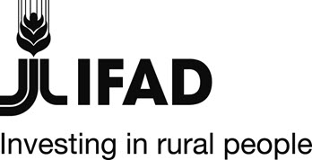 |  | 

Togo

GRANT - TOGO - GEF 4570
Adapting Agriculture Production in Togo (ADAPT)

GEF/LDCF Terminal Evaluation Report Summary

ADAPT at a glance
Country | Togo
Project Name | Adapting Agriculture Production in Togo (ADAPT)
Key Dates
IFAD Approval | Signing | Effectiveness | Mid-Term Review | Original Completion | Actual Completion
10 October 2013 | 11 December 2013 | 11 December 2013 | 16-27 November 2015 | 31/12/2016 | 30/09/ 2017
Original Grant Closing | Actual Grant Closing
30/06/2017 | 30/09/2017
Project Financing
GEF Grant | Million USD | 5,35 | % disbursed | 46,69 %
Government | Million USD | 1,28 | % disbursed | 30 %
Actual Costs and Financing (USD)
Component | GEF Grant | Government | Total
Component 1. Mainstream climate change adaptation tools in agricultural production systems | 1 144 000 | 314 902 | 1 458 902
Component 2. Vulnerable agricultural production systems adapted to current and future climate impacts | 3 263 000 | 764 894 | 4 027 894
Component 3. Information Education and Communication on Climate Change | 267 000 | 153 100 | 833 645
Component 4. Project management and M&E | 267 000 | 54 145 | 321 145
TOTAL | 5 354 546 | 1 287 041 | 6 641 586

Budget disbursed (USD)
Component | GEF Grant | % | Government | % | Total | %
Component 1 | 903 325,54 | 16,87%
Component 2 | 1 209 755,15 | 22,59%
Component 3 | 127 717,90 | 2,39%
Component 4 | 259 110,92 | 4,84%
TOTAL | 2 499 909,51 | 46,69% | 386 035 | 30% | 2 885 944,51 | 43,45%

Number of Beneficiaries
Target |  | Result | Women
25 000 |  | 39 311 | 17 690 (45%)
Project Objective
ADAPT's development objective is "to mitigate the impact of climate change on vulnerable groups and natural resources to make agricultural production and food security sustainable". This objective is broken down as follows:
- Environmental Objective, which is to promote the integration of climate parameters into agricultural planning and production systems supported by resilience of natural resources outside flood-prone (or at-risk) areas; and
- Development objective which is to strengthen the capacity of institutions for the sustainable improvement of food security and income of agricultural producers.
Country Partners
Executing Agency | Ministry of Agriculture, Livestock and Hydraulics
NGOs/civil society | INADES, AGIDE, CADI Afrique, Consortia d’ONG
Other | ICAT, ITRA, DE, DPA, DRF, DGMN, DRAEH, ODEF, ANGE, DSID

Map of project areas
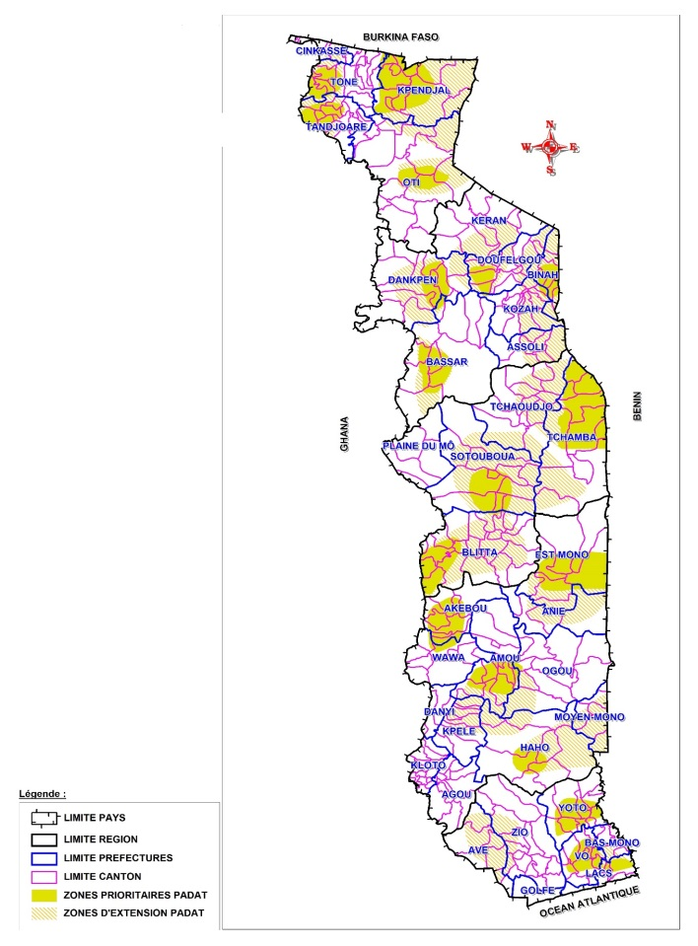 | 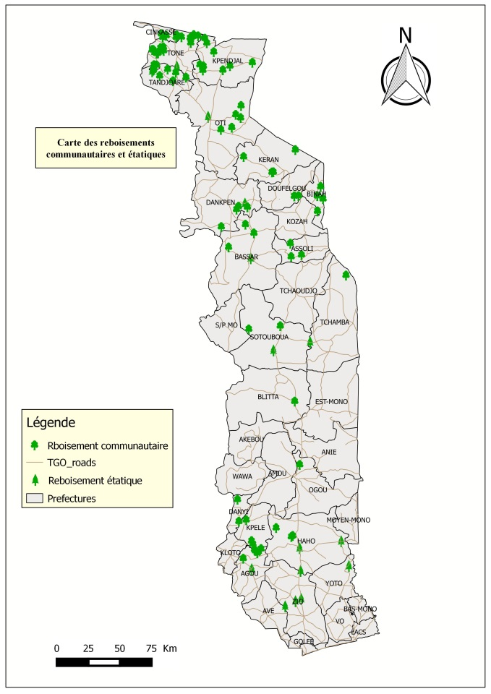
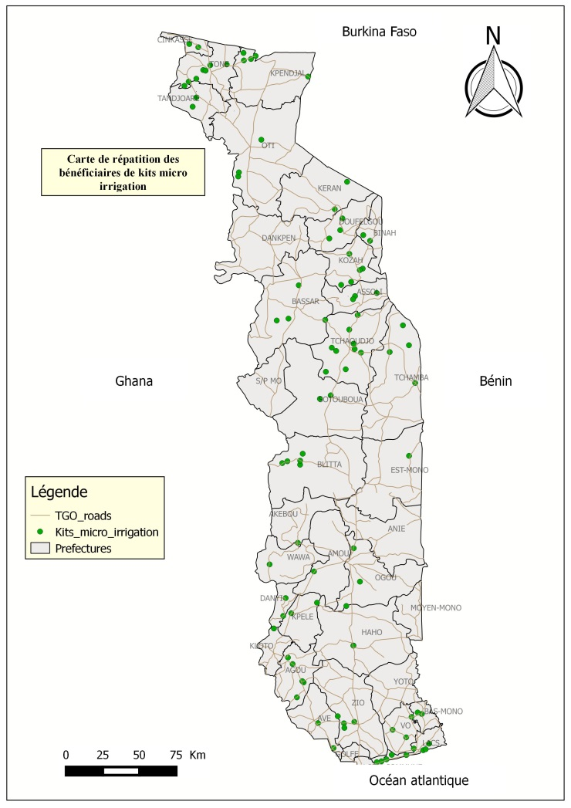 | 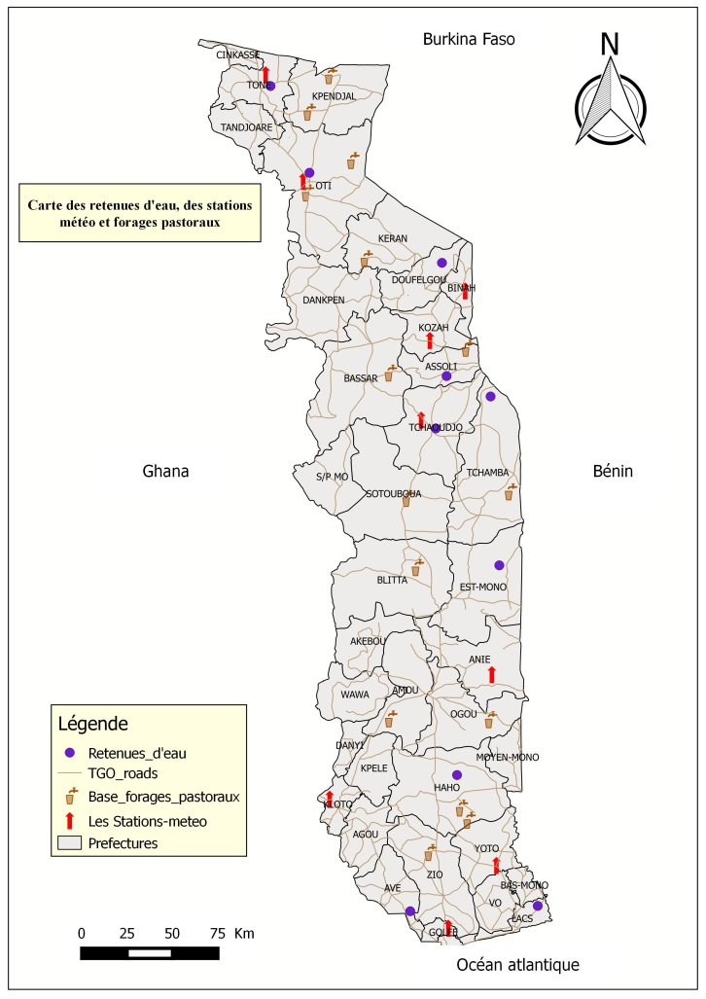

Project overview
- The project "Adapting agricultural production to climate change in Togo - ADAPT" was financed by a grant from the GEF/LDCF (5.35 million USD) and the Government of Togo (1.28 million USD). The signing of the grant agreement took place in December 2013. The GEF project was conceived as additional funding and an integrated component of the Agricultural Development Support Project in Togo (PADAT), which started in 2011, and was funded over the period 2011 - 2016 by IFAD, the Global Agriculture and Food Security Program (GAFSP) the Government of Togo. The completion and closure dates of the project have been aligned with those of the PADAT, respectively 31 December 2016 and 30 September 2017. Its initial implementation duration planned for five years in the project design report was in fact reduced to about three years.
- The ADAPT project was to add a climate change adaptation dimension to PADAT, while complying with the measures recommended in the National Adaptation Action Plan (NAPA). It initially concerned the same areas of intervention, in five regions of the country, but extensions had to be made during the project to be able to carry out certain activities. The project targeted the same target population as PADAT, which included 107,500 of the most vulnerable smallholder farmers, including women and youth, with the more specific goal of directly reaching 25,000 people. The implementation modalities involved key institutional partners and NGOs, which have been involved in its implementation.
Project goal and objectives
- The main objective of ADAPT was "to mitigate the impact of climate change on vulnerable groups and natural resources to make agricultural production and food security sustainable". This objective is broken down into an environmental objective, "to promote the integration of climate parameters into agricultural planning and production systems supported by a resilience of natural resources outside flood-prone or at risk areas"; and a development objective, "to strengthen the capacity of institutions for the sustainable improvement of food security and income of agricultural producers". The project was structured into three operational components and one management component: (i) Mainstream climate change adaptation tools in agricultural production systems; (ii) Vulnerable agricultural production systems adapted to current and future climate impacts; (iii) Information Education and Communication on Climate Change; (iv) project management and monitoring and evaluation. The three operational components constituted component 4 of the PADAT project.
Project relevance
- The project objective and planned activities fit well into the strategies and priorities of the GEF, IFAD and the Government of Togo and respond well to the concerns of the rural population with regard to climate change adaptation and mitigation measures implementation. The articulation and complementarity between ADAPT and PADAT was good, but in practice the synergies were difficult to implement due to a lack of coordination in the planning of various PADAT activities and to recurrent staffing problems in the coordination and administrative functions of the project. In addition, the actual capacities of some key partners were not sufficiently apprehended during project design. These shortcomings had a very significant impact on the project results. Given these elements, the relevance of the project is considered moderately unsatisfactory.
Project effectiveness
- The results of ADAPT are globally disappointing because although many activities have been initiated, most of them were unfinished due to insufficient or absent equipment, lack of training and long-term advisory support, insufficient follow-up period for to be able to determine the success or otherwise of achievements, etc. This situation can be explained in particular by the shortening of the duration of implementation from five to two years due to the long delays in recruiting staff dedicated to the project within PADAT and the delay in contracting implementation partners, but also by the lack of a project review (volume of activities) or its implementation approaches, despite the recommendations of the midterm review mission.
- In terms of successes, the project has enabled (i) to raise awareness about climate change, which results in a better consideration of this issue by both the population and the institutional and private actors of rural development. (ii) to promote the use of organic products for crops (manure and treatments) which have a very positive impact on the productivity and quality of production, and (iii) to conduct a reforestation campaign in the classified areas managed by the State and on community lands. The project has also tested climate change adaptation and mitigation measures such as market gardening under micro-irrigation, beekeeping, agro-forestry practices, improved varieties of cereals and cassava that are more resilient to the climate hazards. On the other hand, fisheries and aquaculture activities could not be completed because the development works were not completed in time and the water and soil conservation interventions were not realized as the works that had to be carried out by PADAT from other sources of funding experienced significant delays in implementation. Support to national structures in charge of meteorology, livestock farming or ecological monitoring (bush fires) resulted in equipment endowments and the construction of some works (pastoral boreholes), but their valorisation as part of the project was not possible due to lack of time and the sustainability of these achievements is not ensured. In terms of efficiency, the overall performance of the project is rated as moderately unsatisfactory.
Project efficiency and partnerships
- The project has experienced significant difficulties in its implementation related to the staffing problems experienced by PADAT (mobility of key personnel, vacant positions, and functions performed by temporary workers) and the complexity and the heaviness of the procurement and contracting procedures with the partners. The prolonged absence of a financial officer and the replacement by insufficiently trained staff led to cash flow difficulties at the end of the project, while it was still in full implementation due to its late start. The disbursement rate of the project is 46.69% for the GEF grant as of 30/09/2017 and 30% for the Government’s contribution. The low disbursement rate of the Government contribution is due to the fact that it consisted exclusively in duties and taxes exemption. The steering committee should have taken into account the implications of a significant reduction in the duration of implementation on the project, in a context marked by the difficulties affecting the PADAT, by drastically reviewing the project’s objectives and targets during the mid-term review in 2015. For this reason, the quality of supervision by IFAD and the Government is rated as moderately unsatisfactory, as is the performance of the partners as some key partners have shown significant limitations in terms of operational capacity.
Project impacts
- The effects and impacts of the project, although difficult to measure after such a short implementation period, have been appraised through stakeholder workshops and discussions with partners and beneficiaries. Globally, the project interventions were appreciated because they led to behavioural changes within communities facing climate change and because they proposed solutions and adaptation measures for a more sustainable, diversified and productive agriculture. Community empowerment and the logic of partnership, including between institutions and with NGOs, were also welcomed. It is therefore a positive appreciation of the prospects in which the project guided the beneficiaries and partners. The project reached 39,311 people which is a good result for the 25,000 people initially targeted.

Sustainability, Innovation, Knowledge Management and Scaling
- The project performance in terms of sustainability is considered moderately satisfactory as the technologies and approaches proposed employ methods and practices that are adapted and replicable by beneficiaries and partners. Only water reservoirs, and to a lesser extent drip irrigation kits, are important investments that could be problematic in scaling up, since a lot of technical and management trainings planned by the project could not be carried out, or only partially. The sustainability of certain achievements (management committee, producer organisations, use of certain equipment) is not ensured. Although some activities could not be completed (fish farming, dissemination of improved varieties, etc.), the project has tested multiple innovations in the Togolese context (drip irrigation, Integrated Management of Fertility, Water and Pests by Mushrooms products (GIFERC), use of local species for reforestation, modern beekeeping, selection of improved varieties, etc.). Some of these innovations are being scaled up such as GIFERC products, agroforestry parks and landfills in classified forest areas. In terms of knowledge management the project has not been able to produce the planned studies. However, awareness raising posters on climate change and a fact sheet on the Taungya method of maintaining reforestation plots were produced.
Lessons learned
- Based on ADAPT results at completion, there many lessons learned in terms of (i) policies and strategies, (ii) implementation approaches and arrangements, and (iii) planning, management, coordination, monitoring and evaluation.
Development and implementation of agricultural policies and strategies
- Promotion of market gardening with drip irrigation. Market gardening under micro-irrigation, combined with fertilization and biological or reasoned treatments and composting, makes it possible to secure production in a context of climate change (reduction of water availability and / or accessibility, increased water stress, etc.) while improving the sanitary and nutritional quality of the products. The large-scale development of this technology implies, however, the establishment of an investment support or subsidy policy, and a structuring of the sectors to improve the conditions of access to equipment and inputs as well as to the market in a regional exchange framework.
- Climate change adaptation measures for small farms. Awareness of the reality and effects of climate change translates into a high demand for farmers' innovations and a high capacity for change in their farming practices. This is reflected in the adoption of improved varieties and the introduction of new crops or in learning new techniques for conservation and sustainable soil management and agroforestry, including the use of manure from livestock. Rural development policies will have to take into account this demand of producers in terms of innovations and support their desire for diversification.
Intervention methods
- The association of beekeeping with community reforestation operations. The economic dimension of beekeeping, and the interest of the populations in this activity, represent an important motivation for the preservation, the extension and the enrichment of the wooded areas. The establishment of hives in the reforested areas increases beekeepers motivation to building firewalls, monitoring of bush fires and maintenance of plants.
- Reforestation generating income in the short and medium term for households. The regeneration of tree cover is clearly identified by the people as a means to limit the effects of climate change and to restore better living and production conditions. Reforestation is a demanding activity in terms of work and monitoring and it is sometimes difficult to conduct in a community context (availability of land and guarantee of medium and long-term rights on reforested areas). The promotion of individual reforestation (orchard, hedge and grove) with improved varieties of species with high economic value is popular with rural populations because it helps to reconcile the fight against climate change and meeting the financial needs of households.
- Maintenance of plots reforested by farmers. Cultivation in reforestation plots (taungya method) during the first three years improves very significantly the plants survival rate, growth and development. In addition, this technique allows landless farmers to have a permanent access to crop plots by moving in state forests. They become itinerant farmers using one plot for two or three years and then move on to the next.
- Research and development coupled with sensitization. Sensitization and promotion of adaptation measures have been powerful tools for raising awareness among vulnerable groups and rapidly adopting climate change adaptation practices. ADAPT's experience shows that behavioural changes are best achieved when interventions combine advocacy and pilot operations that contribute to the community/household economic strengthening perspective. Indeed, the benefits associated with the pilot operations conducted through the project (beekeeping, reforestation with economically valuable species, market gardening, drip irrigation) have allowed to observe profound changes in people's attitudes towards natural resources and the adoption of new technologies.
- Outsourcing of implementation responsibilities to deconcentrated technical services and NGOs and decentralization of the steering function. The strategy of outsourcing and delegating implementation responsibilities (known as faire-faire) and the strong involvement of partners on the ground have been an effective implementation arrangement for institutional sustainability. From this point of view, the involvement of NGOs is particularly noteworthy. Even if they were recruited as providers, they behaved more like partners by mobilizing their resources and sometimes even pre-financing certain acquisitions to cope with their commitments to the beneficiaries. This is partly due to the fact that NGOs, particularly those with strong local roots, have in some cases, and to the extent that they correspond to the project criteria, proposed the beneficiaries with whom they have worked. In addition to that, local NGOs have been selected with support from deconcentrated technical services, which further enhances the prospects for sustainable collaboration of rural development actors at the local level.
- The ''faire-faire'' strategy is therefore a successful approach if administrative pitfalls are avoided. It is the partners, and thus the mode of intervention by this approach that have largely contributed to the results obtained by the Project. But this approach has been strongly thwarted by the significant delays in contracting, particularly for the partnership agreements. The lack of anticipation of the PADAT in the preparation of the implementation agreements for ADAPT is regrettable because negotiations could have been started as soon as the grant agreement was signed and without waiting for the recruitment of the ADAPT officer, which would have saved several months of implementation and made it possible to better take into account the duration and the complexity of the procurement procedures at the national level.
Planning, management, coordination and monitoring and evaluation
- Difficult implementation because of the complexity of the project and its lack of autonomy. ADAPT was designed to reinforce the objectives of the PADAT while allowing the implementation of actions included in the NAPA without any direct relationship between the different sectors concerned. This resulted in a project that was difficult to understand in its organization, with a complex design document and no clear boundaries between components and subcomponents. This complexity was further reinforced by the integration of the project into the PADAT and its very weak autonomy at the operational level as well as the coordination and management functions.
- The integration of ADAPT into PADAT reduced the visibility of the project and its objectives. The integration of ADAPT into PADAT has made us forget that it was a project as such, subject to a specific design report and grant agreement and with its own objectives which have not all been integrated to the logical framework of PADAT. The lack of specific follow-up (supervision reports, RIMS, AWPB, etc.) and the fact that ADAPT started two years after the PADAT, also contributed to this lack of visibility, which certainly affected its implementation.
- Inefficiency along the procurement process. The procurement process became more complex during 0the project implementation with the introduction of a visa from the Minister of Economy and Finance which lengthened the control and approval circuit. The cumbersomeness of the procurement procedures is a real problem in projects’ implementation and the PADAT experience shows that the accumulated annual delays in the mobilization process of the implementation operators is the main cause of its low level of implementation.
- Long delays in the recruitment process. Recruitment delays have had a significant impact on the project performance, whether it was the ADAPT project manager recruitment or the operational coordination team, which was not yet set up at project completion.
- An effective monitoring and evaluation system involving all implementing actors. The monitoring and evaluation of the PADAT is operational, participatory and makes available the necessary information to pilot and manage the project even if some prerequisites, such as reference situations are not available. The main achievements of the system are mainly due to the skills and motivation of the interim PADAT M&E officer, who supervises the monitoring and evaluation unit of the project. The project’s experience shows however, that the performance of its M&E system depends not only on the M&E officer skills, but is also strongly influenced by the involvement of all implementing partners in its operationalization.
Conclusions
- The ADAPT project, even though it has not achieved the expected quantitative results and many activities could not be carried out, has largely contributed to raising awareness on climate change and its impacts. It has made it possible to promote and pilot with the populations multiple adaptation measures, some of which are already beginning to be disseminated independently of the project. The very short duration of the project and the cash flow difficulties during the last quarter of implementation have never allowed it to reach its cruising speed. It is due to the commitment and voluntarism of the project staff and operational partners that some significant results have been achieved.
- Conclusions on implementation performance and project results. Based on the cumulative outputs of the project by component as of 31 December 2016, ADAPT's performance is rated as moderately unsatisfactory because. Although not all major products in the logical framework have been achieved, some important effects are to be used as a basis or benchmark for future climate change adaptation interventions. Overall, ADAPT's achievements have contributed to beneficiaries' satisfaction in terms of increased production of maize and rice, food security, increased income, protection of natural resources , and climate change adaptation. This was confirmed by the participants in the stakeholder workshops. Finally, the ADAPT project has implemented innovations highly appreciated by farmers organisations, particularly with regard to the development of new activities in the national context, aimed at strengthening household resilience to climate change through diversification of agricultural activities (modern beekeeping, cashew orchards, agroforestry, GIFERC products, etc.).
- Main constraints and limitations of implementation. They mainly include: (i) delays in the implementation of lowland development, (ii) cash stress during the last half year of implementation; (iii) the slow process of recruiting key coordination staff; (iv) the limited capacity of certain institutions supported by the project, and (v) the very short duration of implementation which was reduced to two years. The implementation team sought to implement all activities over two years instead of five, resulting in an AWPBs representing 80% of the total project budget for the last year. The project team did not benefit from strategic reorientations that would have been essential to the achievement of the project’s objectives and could have justified an extension of the project.
Recommendations
- The recommendations mainly concern post-project sustainability, the design and implementation of policies and strategies as well as new projects and programmes.
  - Carry out a review of beekeeping interventions in order to develop a national strategy to promote this activity by integrating the interrelations with forestry activities, particularly reforestation.
  - Develop a national strategy for irrigation development, including drip irrigation and micro-sprinkling, taking into account issues of access to water, access to equipment and pumping technologies (by giving priority to renewable energies), and by building capacities on farm management and structuring irrigated value chains.
  - Conduct a capitalization study of the experiences and good farming practices in the Sahel countries in order to integrate them into agricultural development strategies to cope with climate change. Farmers confronted with climate hazards for several decades have developed techniques and adaptation strategies that could contribute significantly and rapidly to reducing the effects of climate change on agriculture in central and northern Togo. Continue sensitization and training on climate change and ensure the dissemination of adapted varieties of rice, maize and cassava as well as the various good practices tested within the framework of ADAPT which have received very positive feedback from the affected populations.
  - Identify experiences tested by other projects and accepted by financial and technical partners that had impacts in terms of reducing the duration of the contracting and procurement procedures. Indeed, the slowness in the procurement process (mobilization of implementation operators, acquisition of equipment and construction of infrastructure) was a real obstacle for PADAT in carrying out certain activities, which partly explains the unfinished achievements at the end of the project.
  - Develop and implement a capacity building plan for the operational/managerial directorates in order to create a pool of confirmed skills for a more efficient project management.

TER Rating Matrix
Criterion | Rating
Project performance
- Relevance | 3
- Effectiveness | 3
- Efficiency | 3
- Sustainability | 4
Additional evaluation criteria
- Targeting and outreach | 3
- Gender equality and women’ s empowerment | 3
- Innovation | 4
- Potential for scaling-up | 3
Project impacts
- Households ‘incomes and assets | 4
- Food security | 4
- Human and social capital and empowerment | 3
- Agricultural productivity | 4
- Access to markets | n/a
- Environment and natural resources management | 4
- Adaptation to climate change | 4
- Institutions and policies | 4
Partners performance
- IFAD’ s performance | 3
- Government performance | 3
- Service providers performance | 4
- Farmers organisations performance | 4
Overall project performance | 3
Overall impact of the project on rural poverty | 3

